Final Project Description: University Website Redesign Report

**Chapter 1: Design Critique Learnings:**

1)Visual Design Critique:

**The visual design of the UNC Charlotte website exhibits several strengths that enhance user experience. The clear navigation menu facilitates easy access to information, while high-quality imagery provides a visually appealing representation of the campus. The website's fast loading speed contributes to a smooth user experience, and the emphasis on community involvement fosters a sense of belonging.**

**However, there are areas for improvement. The website uses various font styles with different typographies. The font size in the page can be increased and also they can add new styles rather using complete text by Neusa Next style. On larger screens, excessive transitions between sections create confusion, particularly in the scrolling experience. Certain buttons, like "Read More," lack visibility and may lead to user confusion. Additionally, there are missed opportunities for more creative typography in headings and improvements needed in whitespace utilization for better content separation.**

**Despite these drawbacks, the visual design aligns well with the website's purpose of providing information about the university. It instills trust through consistent branding, but attention to detail, such as button visibility and creative typography, could enhance the overall user experience.**

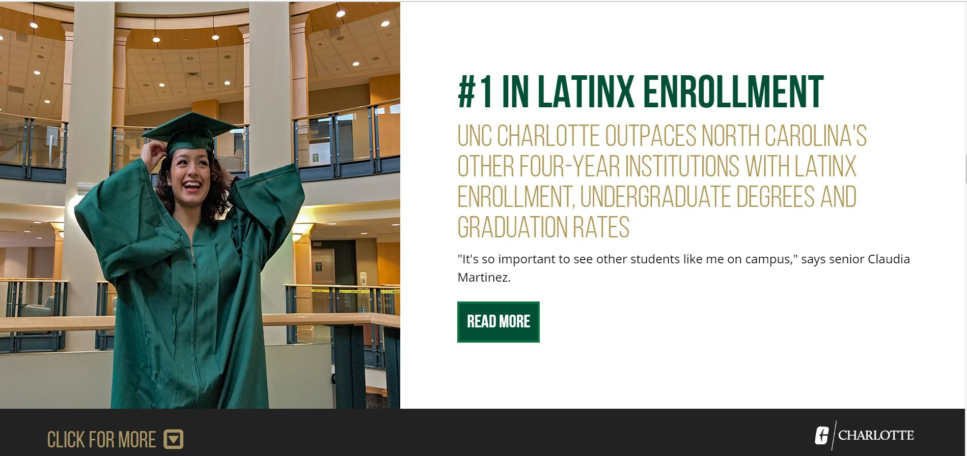

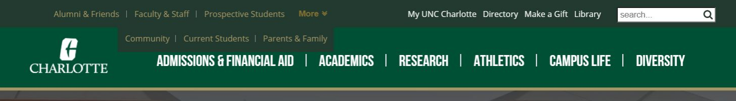

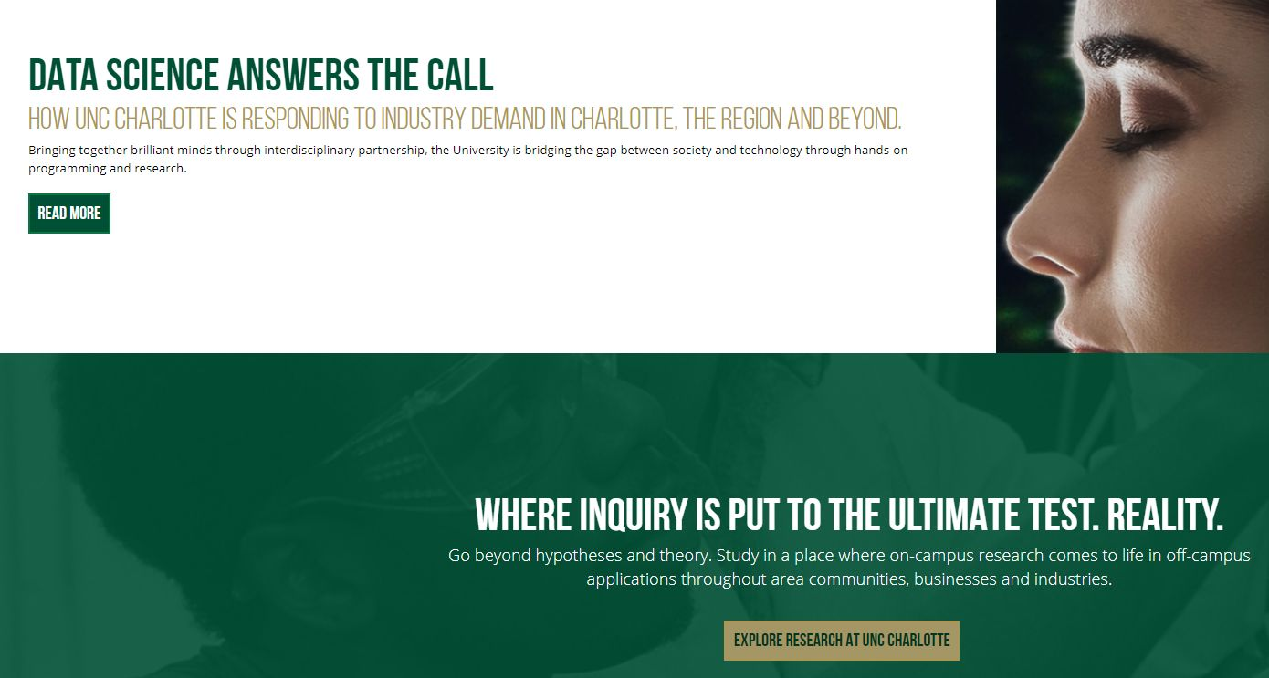

2)Interaction Design Critique:

* **Consistency:**

**Observation: Footers remain consistent across pages, ensuring a cohesive user experience.**

**Critique: Header elements lack complete consistency, suggesting a need for uniformity.**

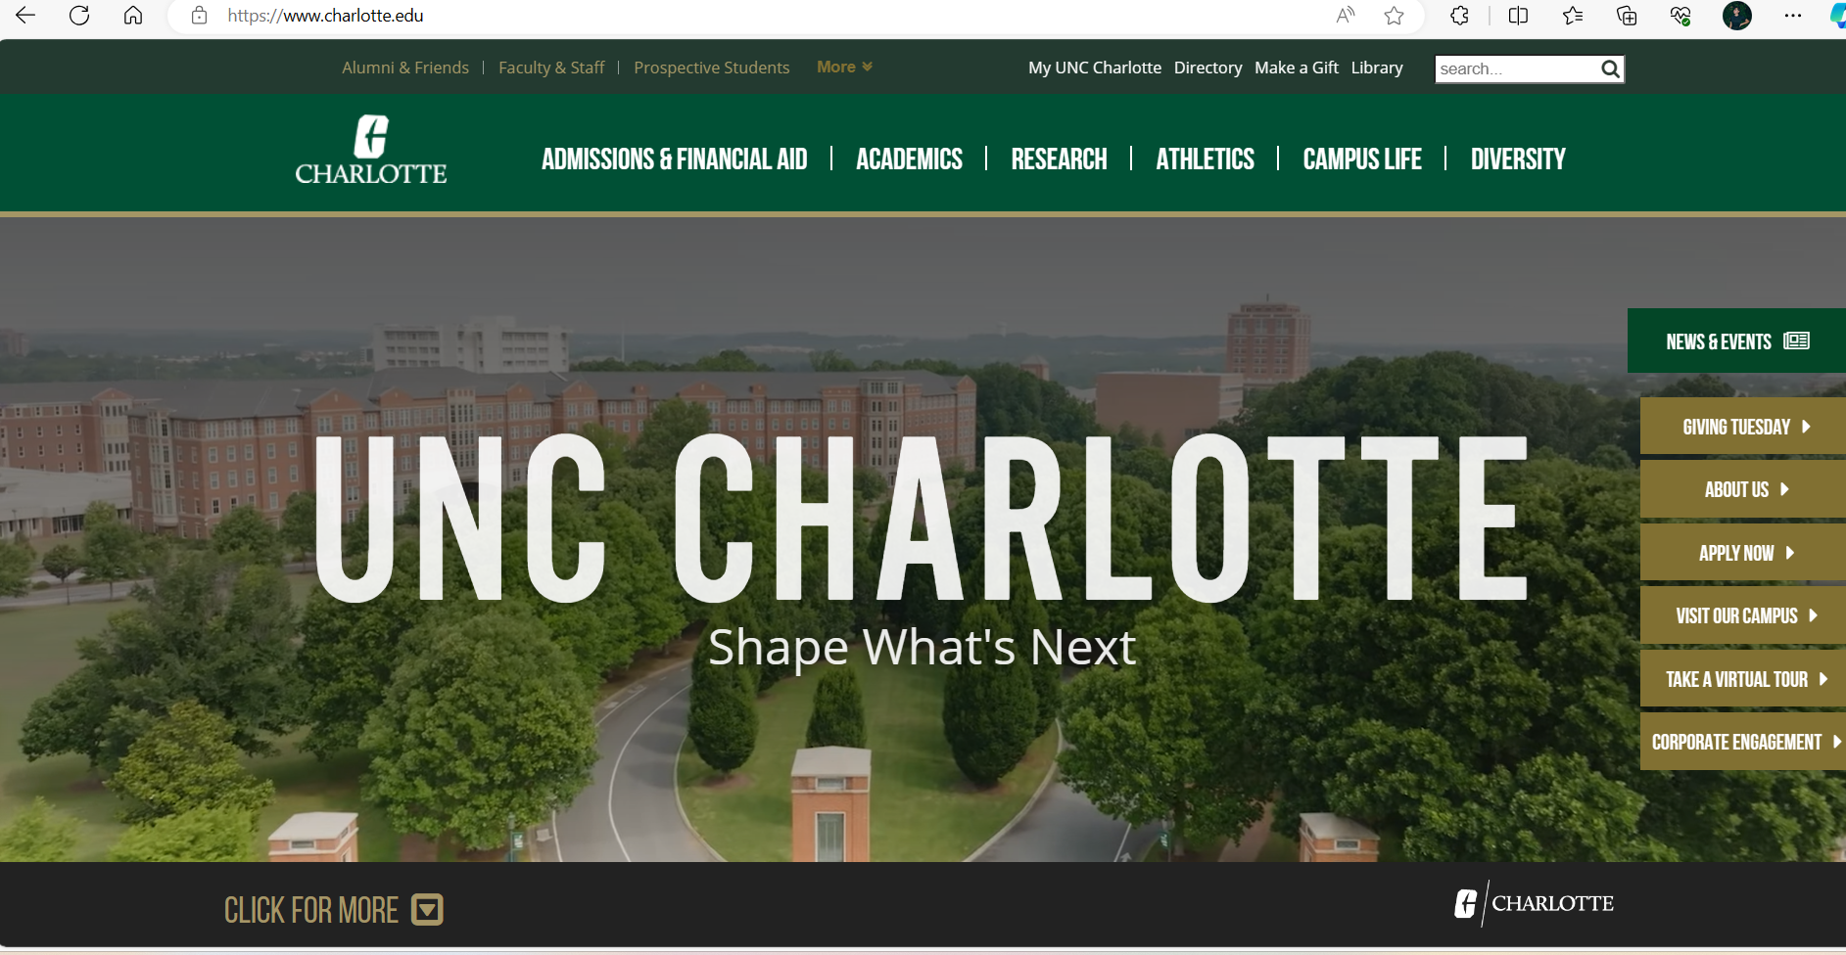

* **Minimalism:**

**Observation: Prioritization of important content with purposeful, high-quality images.**

**Critique: Cluttered design with numerous images may impact website loading time.**



* **Discoverability:**

**Observation: Easily discoverable header, footer, and essential information.**

**Improvement: Enhance interaction by adding image view options to engage users further.**



* **Learnability:**

**Observation: Predictable user interface behavior, ensuring confidence in user actions.**

**Improvement: Simplify access to campus links and resources without the need for additional clicks.**

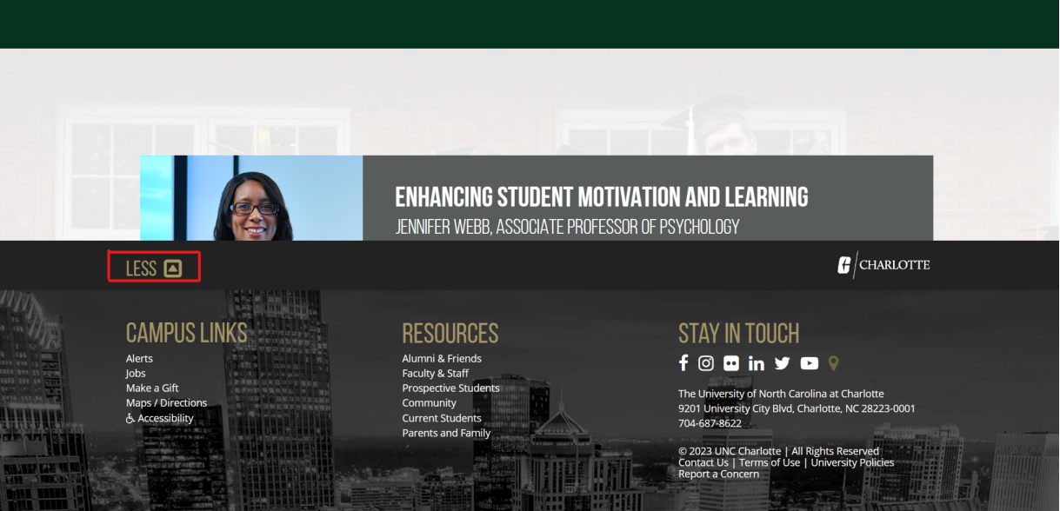

* **Mental Model:**

**Observation: Users navigate effectively, relying on established mental models.**

**Improvement: Introduce more interactive buttons to encourage user exploration.**



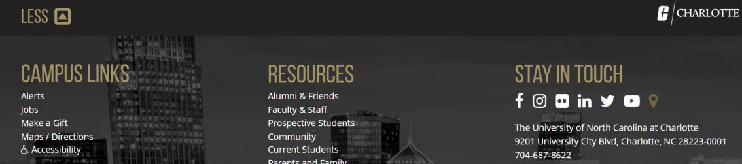

* **Visual Hierarchy:**

**Observation: Important information presented prominently at the top.**

**Improvement: Implement distinct font styles or colors to enhance visual hierarchy.**



* **Affordances and Signifiers:**

**Observation: Clear indications, like the search bar and dropdown symbol, guide user actions.**

**Improvement: Expand the use of icons and interactive elements to improve user interaction.**



* **Constraints:**

**Observation: Login page constraints, such as unsuccessful login attempts.**

**Improvement: Add input validation for login credentials to provide a smoother user experience.**



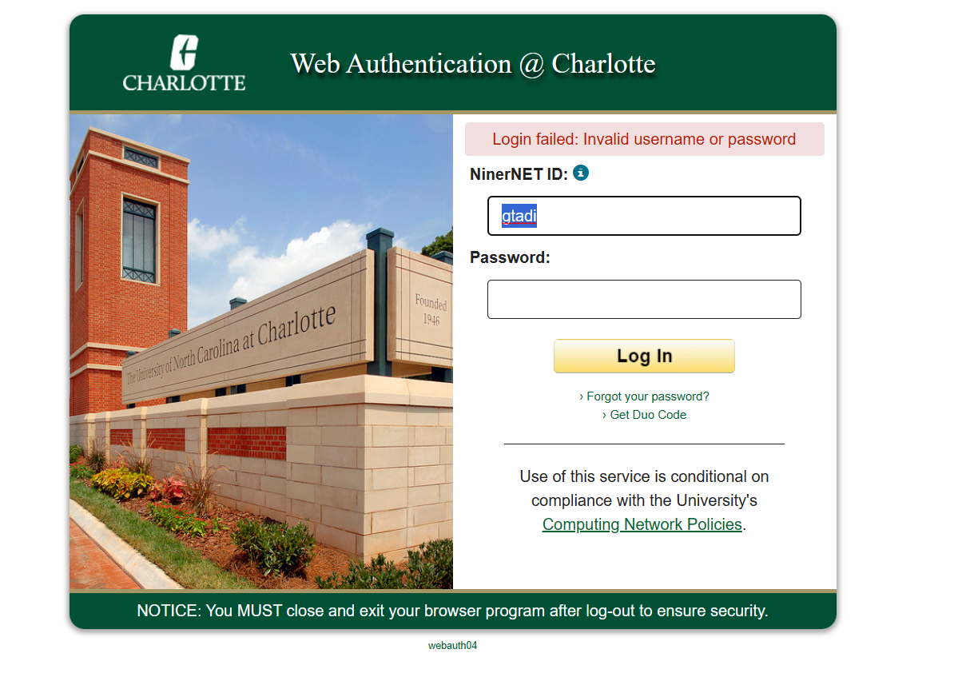

3)Heuristic Evaluation (4 points):

* **Visibility of System Status:**

**Positive: Quick loading of Admissions & Financial Aid page.**

**Negative: Lack of visible indicators during loading; recommend adding subtle animations or messages.**

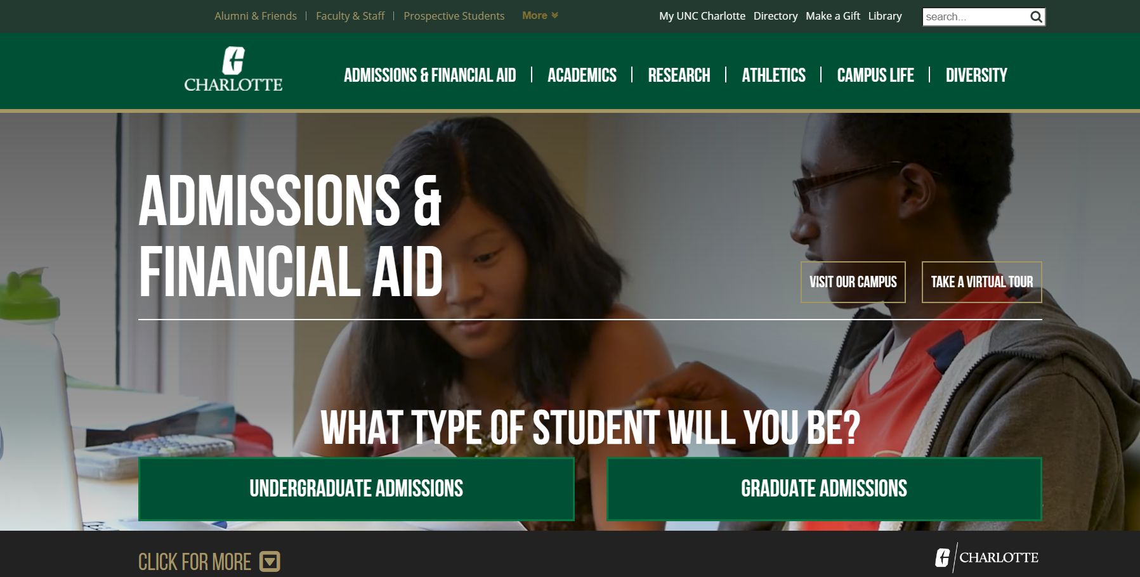

* **Match between System and the Real World:**

**Positive: Clear use of terms like "Admissions" and "Financial Aid."**

**Negative: Possible confusion with unexplained acronyms; suggest using plain language and providing explanations.**

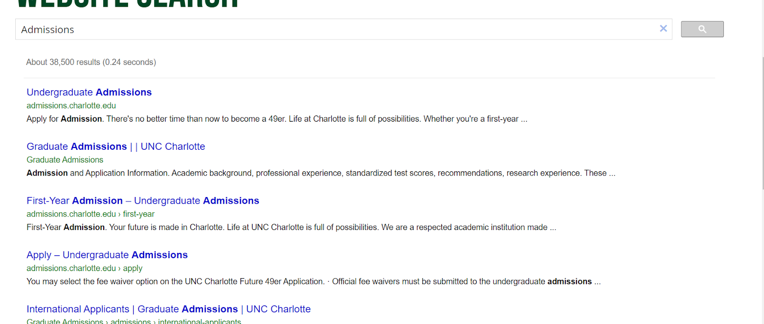

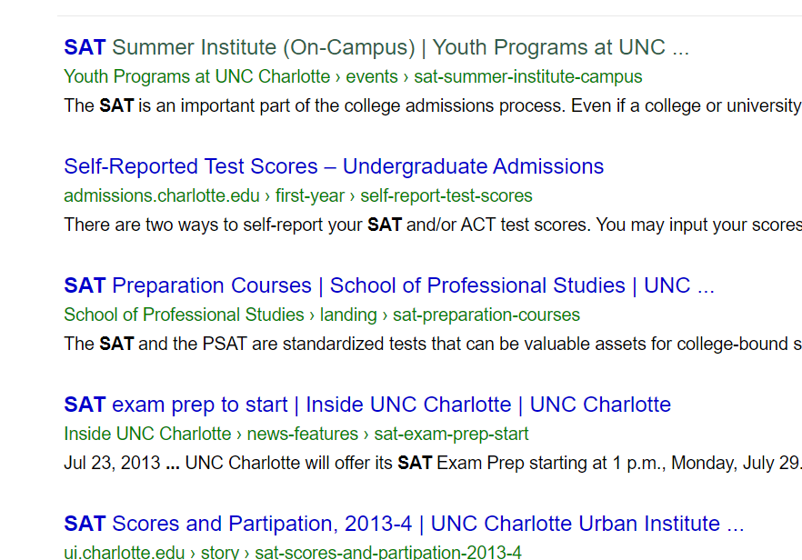

* **User Control and Freedom:**

**Positive: Users can navigate freely.**

**Negative: Overwhelming options; recommend organizing content logically and maintaining a consistent layout.**



* **Consistency and Standards:**

**Positive: Consistent header and footer.**

**Negative: Lack of clear design guidelines; suggest enhancing consistency across all pages.**

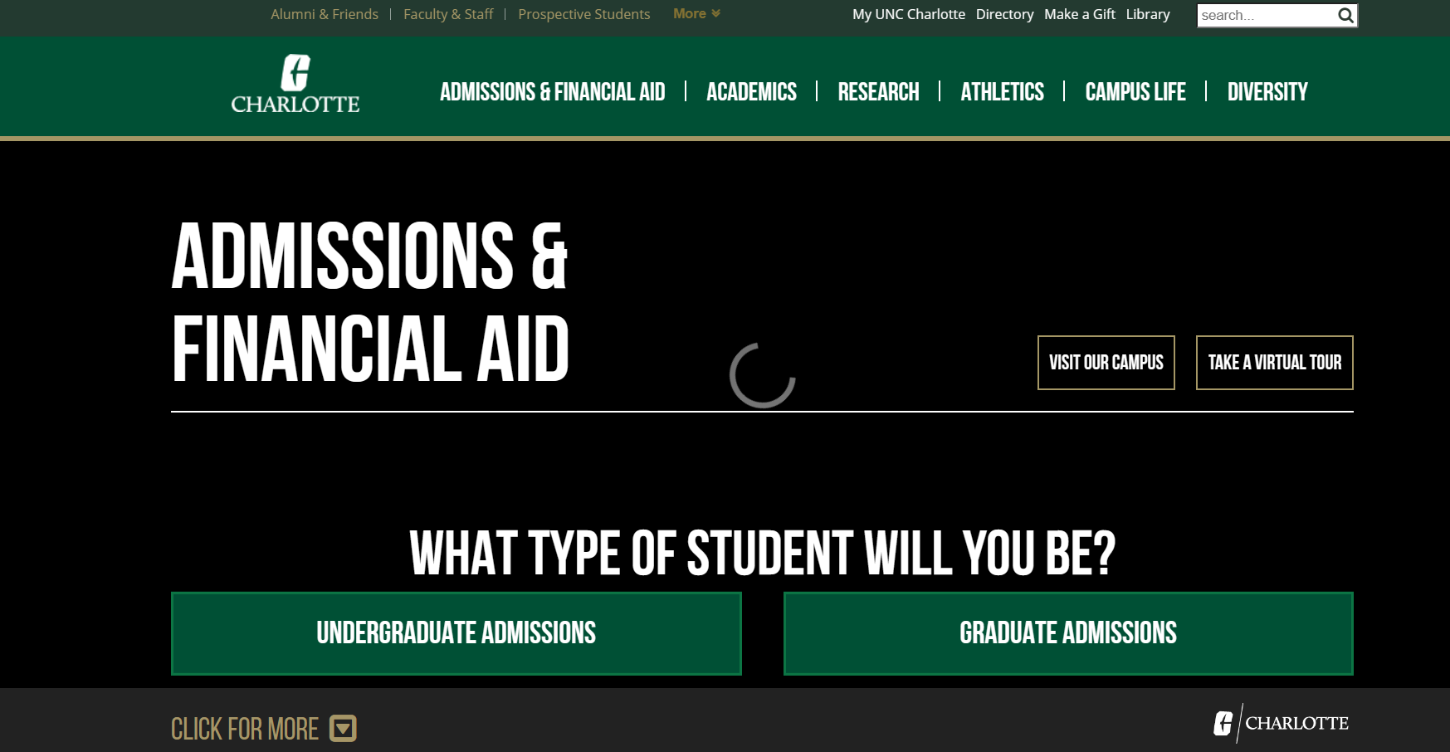

* **Error Prevention:**

**Positive: Warning about duplicate accounts.**

**Negative: Limited error prevention measures; recommend real-time validation and inline error messages.**

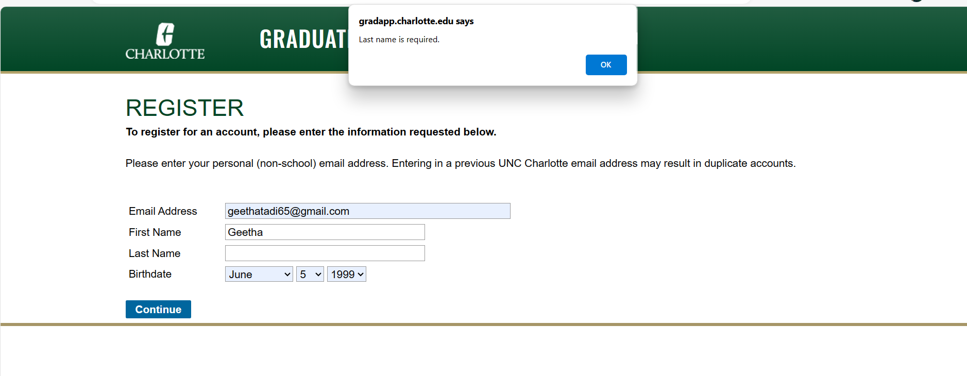

* **Recognition Rather Than Recall:**

**Positive: Clear signs and menus.**

**Negative: Balance needed between efficiency and accessibility.**

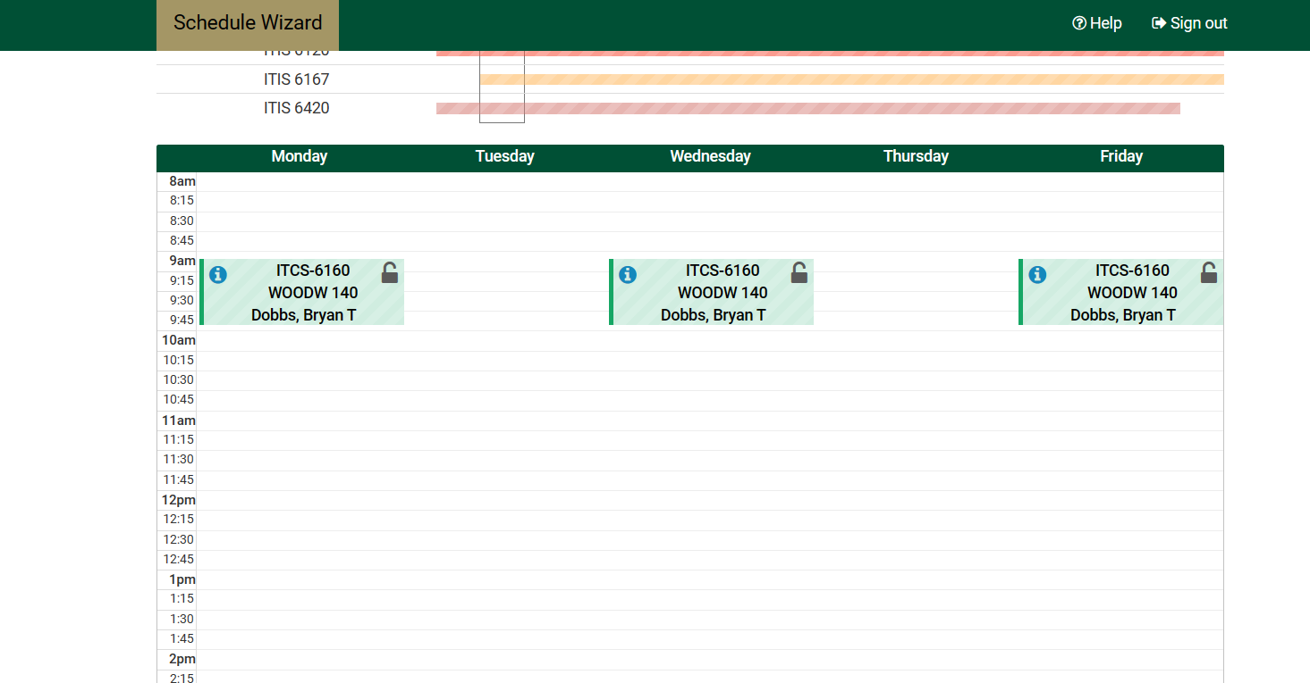

* **Flexibility and Efficiency of Use:**

**Positive: Quick access to important materials.**

**Negative: Potential confusion due to too many options; recommend clear menus and a robust search bar.**

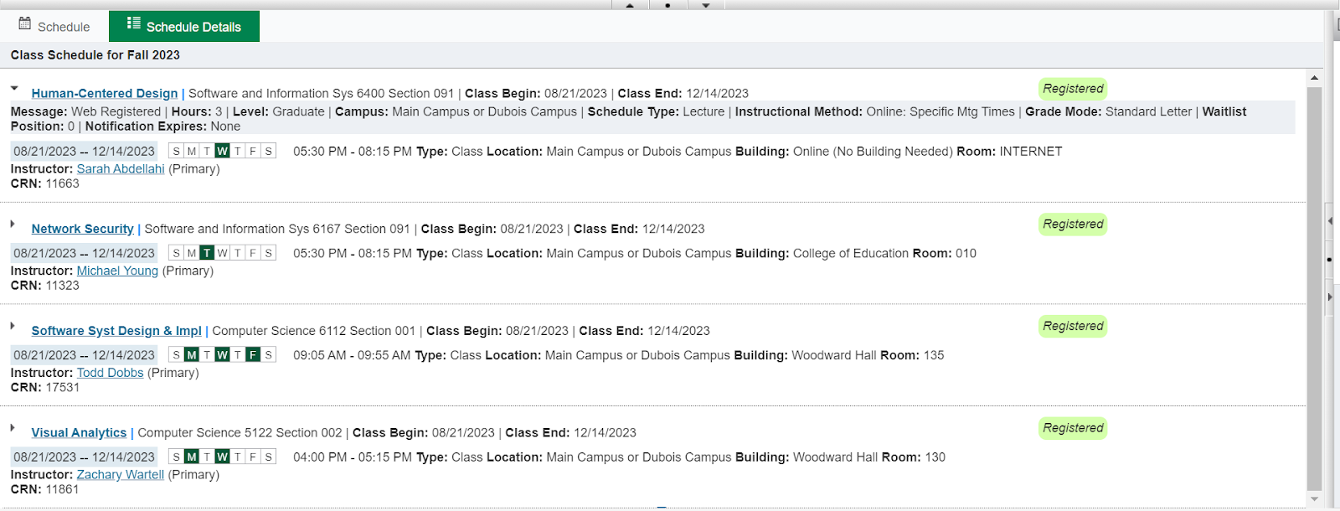

* **Aesthetic and Minimalist Design:**

**Positive: Clean and visually appealing design.**

**Negative: Some sections could be presented more compactly; suggest improving visual hierarchy.**



* **Help Users Recognize, Diagnose, and Recover from Errors:**

**Positive: Absence of major technical errors.**

**Negative: Lack of evident error prevention and guidance; recommend implementing clear error messages.**

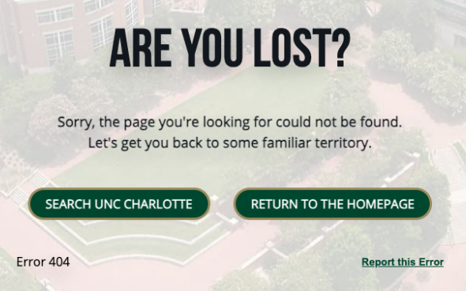

* **Help and Documentation:**

**Positive: Main navigation provides access to potential help sections.**

**Negative: No dedicated "Help" or "FAQ" section; recommend creating one for common user questions.**

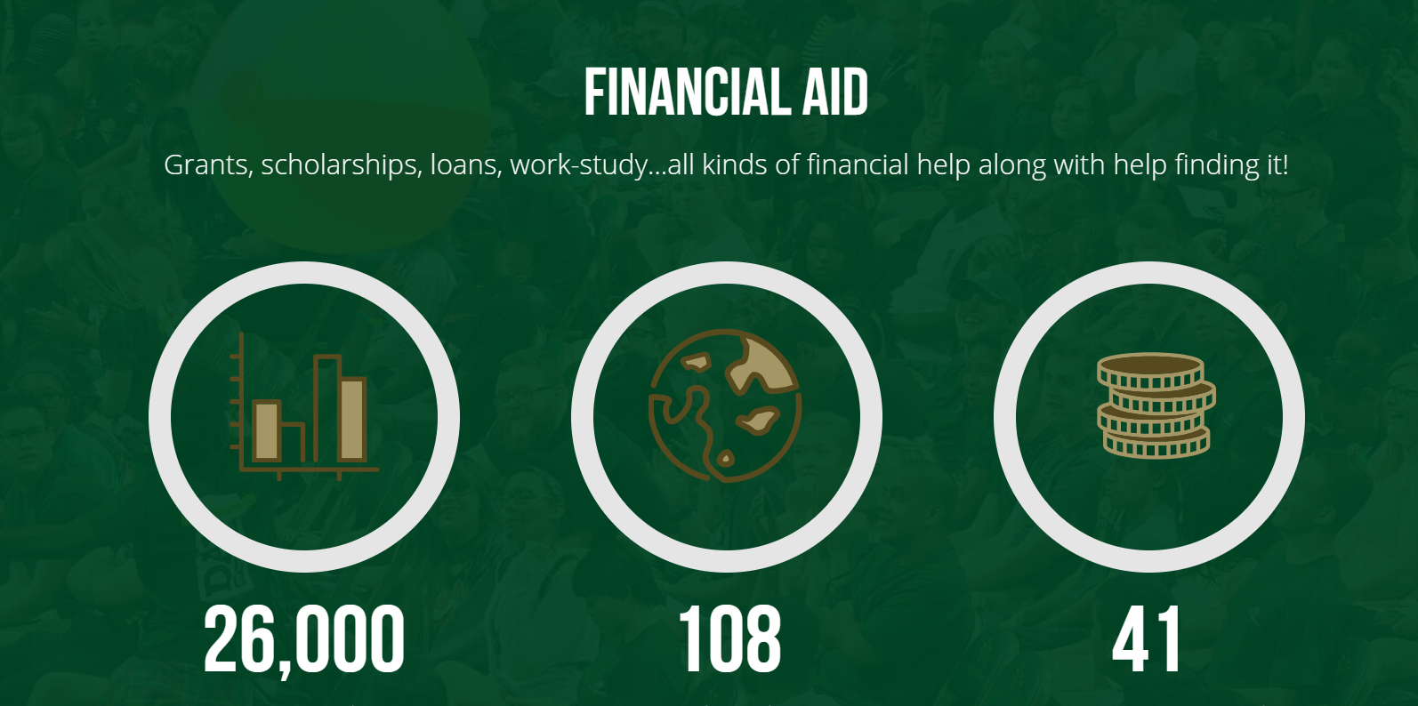

**Chapter 2: Main Personas and Interviews:**

1)Persona Introduction:

Personas are fictional characters representing different user segments, crafted to understand and address diverse user needs and behaviors. They provide a human touch to the design process, aiding in the creation of user-centric solutions. Here, we introduce three distinct personas for the university website:

**Persona 1: Amy - The Prospective Student with Visual Impairment**

Background: Amy, an 18-year-old female from South Carolina, recently graduated and aspires to study Psychology. Living with a visual impairment, clear and inclusive information about admissions and diversity is crucial for her.

Motivations/Goals: Amy seeks statistical information on the college's diversity and inclusive programs. Contact details for diversity programs and guidance from the admissions office are essential for her.

Frustrations/Pain Points: Visual complexities and lack of clear navigation may frustrate Amy. Accessible, well-organized content and a defined Diversity page are vital for her ease of use.

**Persona 2: Lucy - The Current Student’s Grandmother**

Background: Lucy, a 72-year-old proud grandmother from Charlotte, NC, is thrilled about her grandchild attending the university. Her eagerness to visit prompts her to explore the website for logistical and visiting information.

Motivations/Goals: Lucy aims to find location details, visiting days for family, and information on transportation and parking. Her technological limitations make user-friendly navigation and live chat assistance important.

Frustrations/Pain Points: Technological challenges and unclear visiting information might frustrate Lucy. Immediate live chat availability and clear guidance for family visitors are critical for her satisfaction.

**Persona 3: Jose - The Prospective International Student Athlete**

Background: Jose, an 18-year-old male basketball player from Mexico City, dreams of playing college basketball in the US. He is particularly interested in scholarships, team competitiveness, and eligibility requirements.

Motivations/Goals: Jose is driven by the search for athletic scholarships, especially those for international students. Detailed information on the basketball team's stats and eligibility criteria is vital for his decision-making.

Frustrations/Pain Points: Inaccessible international scholarships and undisclosed team statistics may frustrate Jose. A clear presentation of scholarships and transparent athletic criteria are key to his satisfaction.

2)Interview Process Description:

**Interview Type:** To update our personas, we've chosen to conduct semi-structured interviews. Interviews that are semi-structured provide a decent mix of framework and flexibility. This is in line with our objectives since it enables us to have a set of fundamental inquiries to guarantee consistency and depth while also allowing participants to freely build on their ideas and experiences. This strategy guarantees that we collect precise data while being open to new, unexpected ideas.

**Participant Recruiting Method:** A variety of techniques will be used to find interviewees for the sessions. We will first send invitations to participate in the interview process to our current user base via email and in-app alerts. Additionally, we'll publish recruitment announcements on our website and on social media. Active consumers of our product or service who are prepared to give their insights for persona upgrades are required of participants. We may provide incentives, such as gift cards or price breaks on our services, to promote participation.

**Interview Duration:** Each interview is going to be expected to last 20minutes. We can explore specifics and acquire thorough insights within this time range while also respecting the participants' time and availability. To manage participants' expectations and guarantee that we complete the activity within the given time, we will clearly convey the anticipated duration to them in advance.

**Questions asked:**

1)Could you please provide a brief overview of your educational background and life experiences, emphasizing any factors that might influence how you interact with the university website?

2)When you visit the university website, what are your main objectives and goals? What specific short-term and long-term goals do you aim to achieve during your online visits?

3)In your opinion, what specific information or features are absolutely crucial for you when using the university website to ensure your academic and personal success?

4)Considering your experiences, can you share any challenges or frustrations you've encountered while using the university website, and how have they impacted your online experience? Are there any particular pain points or obstacles that you believe need addressing?

3)Persona Development:

**Explanation of Changes:**

Precision and Clarity: The revised question maintains its focus on challenges and frustrations but is more concise and straightforward. It explicitly asks for specific experiences, difficulties, and pain points, making it clear what type of information is being sought.

Clear Intent: The addition of the phrase "Your insights will assist us in improving the website's user experience and addressing potential obstacles" underscores the purpose of the question. It emphasizes that the user's feedback is valuable for improving the website and addressing issues.

These changes enhance the clarity and depth of the questions, ensuring that the interviewee understands what information is being sought and why it is important. The revisions aim to gather more detailed and insightful responses from the interviewees.

**Updated persona:**

Name: Amy

Demographics: 18 years old, Female, Living in South Carolina.

Background: Amy has recently graduated from high school and is eager to find a nearby university where she can pursue a degree in Psychology. Despite her visual impairment, she is determined to navigate the challenges and make informed decisions about her education.

Motivations/Goals:

Amy's primary goal when visiting the university website is to gather comprehensive information about the admissions process.

Understanding the diversity of the school is crucial for Amy as it influences her comfort level in moving out of state for her education.

Amy is specifically interested in statistical information on the college's diversity and the availability of inclusive programs.

Needs:

Essential for Amy is access to contact information for a diversity program department. This is vital for obtaining detailed information about inclusive programs and support services.

Amy requires assistance from the admissions office to guide her toward relevant programs and ensure a smooth application process.

Frustrations/Pain Points:

Amy experiences frustration when encountering overly complex and cluttered information pages on a school's website. Clear differentiation based on criteria beyond just colors is crucial for her to navigate effectively.

The absence of a well-defined navigation bar or a dedicated Diversity page poses a challenge for Amy, leading to confusion about where to find the information she seeks.

Additional Insights from Interviews:

Amy expressed the importance of alt text and descriptive captions for visual content on the website to enhance her understanding.

Emphasized the need for a user-friendly and accessible website design, with a focus on simplicity and clarity in layout and navigation.

**Chapter 2.1 Needs Identified as a Result of Interviews:**

The interviews with individuals who align with the specified persona of a prospective international student revealed several critical needs related to website accessibility, inclusivity, and user support. These needs, identified through participant insights, provide valuable guidance for improving the university website to better cater to individuals with visual impairment and similar challenges:

Accessible Navigation:

Need: Participants expressed a strong need for more accessible navigation features on university websites. Clear and easily navigable menus, headings, and links were highlighted as essential elements for a seamless browsing experience.

Recommendation: Implementing accessible navigation structures, such as descriptive link text and keyboard shortcuts, can significantly enhance the user experience for individuals with visual impairment.

Alternative Content for Visual Elements:

Need: Participants emphasized the importance of having alternative content for visual elements like images and graphics. This includes descriptive alt text and captions that convey the information conveyed by visual content.

Recommendation: Ensuring that all visual elements are accompanied by descriptive text or alternative formats can make the website more inclusive and informative for users with visual impairments.

Customizable User Interface:

Need: Interviewees expressed a desire for a more customizable user interface that allows them to personalize the website according to their preferences. This includes options for adjusting font size, color contrast, and other visual settings.

Recommendation: Implementing features that enable users to customize the visual aspects of the website can enhance accessibility and accommodate diverse user needs.

Comprehensive Accessibility Information:

Need: Participants highlighted the need for comprehensive accessibility information on university websites. This includes clear details about the availability of assistive technologies, accessibility policies, and contact information for support.

Recommendation: Creating a dedicated section on the website that provides comprehensive information about accessibility features, policies, and support resources can help users with visual impairment navigate the online environment more effectively.

User Support and Guidance:

Need: Interviewees expressed the need for readily available user support and guidance features. This includes live chat support, clear instructions on using accessibility features, and assistance in case of technical difficulties.

Recommendation: Implementing live chat support and incorporating clear guidance on using accessibility features can provide immediate assistance to users facing challenges while navigating the website.

Consistency in Design and Layout:

Need: Participants highlighted the importance of consistent design and layout across different pages of the website. Inconsistencies in design elements can be disorienting for users with visual impairment.

Recommendation: Establishing and maintaining consistency in design, color schemes, and layout elements throughout the website contributes to a more user-friendly experience for individuals with visual impairment.

These identified needs underscore the significance of prioritizing accessibility, personalization, and user support in the design and development of university websites. Addressing these needs can contribute to a more inclusive and accommodating online environment for individuals with visual impairment and similar challenges.

**Chapter 3: Top Three Needs and Design Ideas:**

1)Identification of Top Three Needs:

**Need1: Enhanced Accessibility Features:**

The university website lacks inclusive design elements, creating accessibility challenges for visually impaired students like Amy. The absence of alternative text for visuals and unclear navigation hinders her engagement, leading to frustration and impeding access to essential information.

**Need2: Improved Diversity Information Accessibility:**

Amy encounters challenges due to the absence of clear pathways and direct contact points for accessing comprehensive diversity information and support on the website. Obtaining statistical insights about the college's diversity and finding inclusive programs tailored to her unique needs becomes a struggle.

**Need3: Specialized Admissions Guidance:**

Amy's need for tailored assistance and guidance from the admissions office to navigate various programs effectively remains unmet. The lack of direct support specifically designed for visually impaired students acts as a barrier, impeding access to crucial information and hindering her confident exploration of academic programs.

2) Clear selection criteria for top three needs. Well-justified choices. Design Ideas:

**Top Three Needs Selection Criteria:**

1.Impact on User Experience: The selected needs should have a substantial impact on Amy's overall experience with the university website. The chosen needs should address critical pain points that significantly affect her ability to access information and navigate the platform effectively.

2.Frequency and Severity: The frequency and severity of each identified need should be considered. Prioritized needs should reflect issues that Amy frequently encounters and that have a high severity level in terms of hindering her engagement with the website.

3.Alignment with Overall Goals: The chosen needs should align closely with Amy's primary goals when visiting the university website. They should directly contribute to improving her experience in accessing admissions information, diversity details, and specialized guidance from the admissions office.

**Well-justified Choices:**

Enhanced Accessibility Features: This need is foundational as it addresses the core challenge of accessibility for visually impaired students. By improving design elements, alternative text, and navigation, we directly enhance Amy's ability to engage with the website, impacting her overall user experience significantly.

Improved Diversity Information Accessibility: Given Amy's specific interest in diversity statistics and inclusive programs, addressing this need is crucial. Clear pathways and direct contact points for accessing such information align directly with her goals, making it a high-priority requirement.

Specialized Admissions Guidance: As Amy seeks tailored assistance from the admissions office, addressing this need is essential for her confident exploration of academic programs. Providing specialized support aligns with her goals and removes a significant barrier in her journey.

**Design Ideas:**

Enhanced Accessibility Features:

Design Idea: Implement a user-friendly interface with improved contrast, larger font sizes, and clear navigation. Incorporate voice-command options for easy navigation, and ensure that all visuals have descriptive alternative text.

Improved Diversity Information Accessibility:

Design Idea: Create a dedicated "Diversity Hub" on the website, featuring easily accessible statistics, success stories, and information about inclusive programs. Implement a chatbot for immediate queries and establish a direct helpline for personalized assistance.

Specialized Admissions Guidance:

Design Idea: Develop an online guidance portal specifically for visually impaired students, offering step-by-step assistance in program navigation. Provide virtual one-on-one sessions with admissions counselors who have expertise in addressing the unique needs of visually impaired individuals.

**Solution idea1:**

1.Embed alternative text descriptions for images: Ensure all images have concise and descriptive alternative text, enabling screen readers to convey this information to visually impaired users. Clear and structured navigation: Simplify the website's navigation, providing clearly labeled sections and headings to assist users in understanding and traversing the site more easily.

2. Contrast and design optimization: Enhance color contrast and design elements to improve visibility for visually impaired users, such as larger fonts, distinct color schemes, and clear visual hierarchies.

**Solution idea2:**

1.Offer Clear Statistical Information: Present diversity statistics in a structured and easily accessible format, ensuring they are compatible with screen readers and other assistive technologies for visually impaired users.

2.Utilize Interactive Visuals: Develop interactive visual tools or infographics to display diversity statistics, ensuring they are easily understandable and engaging for all users, including visually impaired individuals. Provide direct contact information, such as an email or phone number, for a diversity department or specific staff dedicated to assisting students like Amy in finding inclusive programs.

**Solution idea3:**

1.Introduce Personalized Support: Offer dedicated assistance from the admissions office, assigning staff specifically trained to support visually impaired students like Amy. This support can involve one-on-one guidance through academic program exploration.

2.Ensure support channels, such as helplines or chat services, are accessible to visually impaired students, offering options like text-to-speech functionality and screen reader compatibility. Ensure support channels, such as helplines or chat services, are accessible to visually impaired students, offering options like text-to-speech functionality and screen reader compatibility.

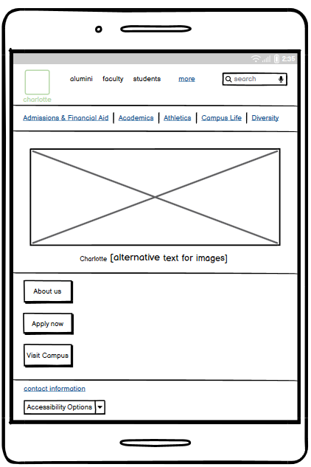 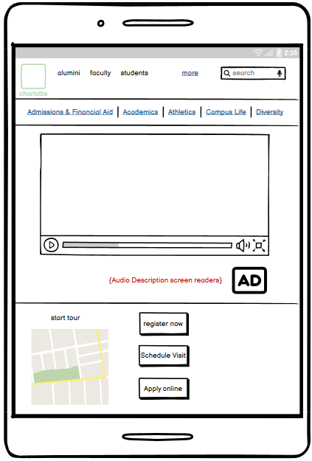

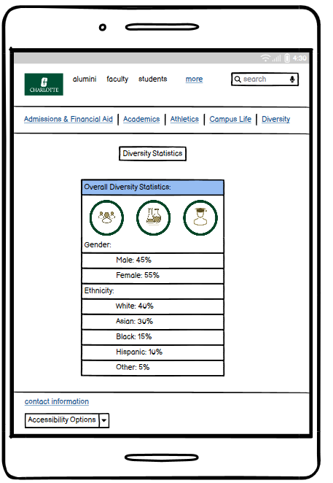

**Chapter 4: Usability Testing:**

1)Participant Recruit:

**Prospective Student in Health Informatics:**

Recruitment Method: Utilized university enrollment data for the Health Informatics program or targeted recruitment within specific academic departments.

Rationale: This participant is focused on Health Informatics, providing insights that might be program-specific. Their perspective is valuable for evaluating the website's effectiveness in catering to the needs and interests of students in a specific academic discipline.

**Prospective Student with Visual Impairment:**

Recruitment Method: Reached out to university accessibility services, online disability communities, and social media groups dedicated to visual impairments.

Rationale: This participant perfectly matches the specified persona criteria, being a prospective student with a visual impairment. Their experience is crucial for evaluating the website's accessibility and inclusivity features.

**Prospective Student who is a Sports Athlete:**

Recruitment Method: Collaborated with sports departments, athletic organizations, or utilized university recruitment events focused on sports.

Rationale: This participant's insights are related to the athletic aspects of university life. Their perspective is valuable for assessing how well the website caters to the needs and interests of student-athletes.

2)Appropriate Selection Criteria for Participants:

The selection criteria for participants are appropriate as they align with the specific goals of the usability testing. Each participant represents a distinct persona, ensuring diverse insights into the university website's performance for different user groups. The criteria consider the unique perspectives and priorities of prospective students in Health Informatics, those with visual impairments, and student-athletes.

3)Clear Rationale for Participant Choices:

Prospective Student in Health Informatics:

**Rationale**: This participant was chosen to provide insights into the website's effectiveness in serving the needs of students in a specific academic discipline, Health Informatics. Their feedback can help identify any program-specific considerations in terms of information accessibility and navigation.

Prospective Student with Visual Impairment:

**Rationale**: This participant was selected to specifically evaluate the website's accessibility features for individuals with visual impairments. Their experiences and feedback are crucial for addressing issues related to inclusive design and navigation for users with visual challenges.

Prospective Student who is a Sports Athlete:

**Rationale**: The inclusion of a prospective student-athlete ensures that the usability testing covers aspects related to sports and athletics. This participant's feedback is valuable for assessing the effectiveness of the website in providing information relevant to student-athletes.

4)Task Assignment:

Task Assignment for Usability Testing:

**Participant 1**: Prospective Student in Health Informatics

Task 1: Explore Health Informatics Program Information

Focus on the Health Informatics program page.

Provide insights into the clarity and accessibility of program-specific information.

**Participant 2:** Prospective Student with Visual Impairment

Task 2: Explore Diversity and Inclusion Resources

Assess the accessibility of diversity-related information.

Share experiences regarding the effectiveness of alternative texts and navigation aids.

**Participant 3:** Prospective Student who is a Sports Athlete

Task 3: Complete a Mock Application

Focus on the overall application process.

Identify any challenges or points of confusion during the application.

5)Clearly defined tasks for usability testing:

**Task 1: Navigating the Website**

Task Description: "Please navigate through the website to explore its different sections and functionalities."

Specific Instructions: "Begin by exploring the main navigation menu. Try to access the 'About Us' section and return to the homepage."

**Task 2: Finding Specific Information**

Task Description: "Imagine you're a prospective student with visual impairment, interested in learning about the admission process. Please locate information related to admissions."

Specific Instructions: "Find details about admission requirements and how to apply."

**Task 3: Accessing Accessibility Information**

Task Description: "Imagine you are a student with visual impairments. Locate the section that discusses accessibility features or support for visually impaired users."

Specific Instructions: "Find information about features like screen reader compatibility or text-to-speech functionality."

**Task 4: Providing Feedback**

Task Description: "Please provide feedback on the website's layout, navigation, and any difficulties you faced during the tasks."

Specific Instructions: "What did you find easy or difficult? What changes would make the site more user-friendly for you?"

6)Follow-up questions:

* Was there anything particularly challenging while navigating the website?
* How would you rate the ease of finding the 'About Us' section and returning to the homepage?
* Were the admission requirements and application details easy to locate?
* What additional information, if any, would be beneficial in the admission section?
* Were the accessibility features clearly defined for users with visual impairments?
* What improvements could be made to enhance the accessibility information?
* Were there any specific areas that you found notably user-friendly or particularly challenging?
* How can the site's layout and navigation be improved for a smoother user experience?

7)Relevant and properly structured follow-up questions:

Question 1: Website Navigation Clarity

Follow-up: "During the tasks, did you find the navigation clear and straightforward, especially when trying to return to the homepage?"

Question 2: Accessibility Features

Follow-up: "As a participant with visual impairment, did you encounter any difficulties related to the website's accessibility features? Were alternative texts and navigational aids effective?"

Question 3: Suggestions for Improvement

Follow-up: "Based on your experience, are there specific areas or features of the website that you believe could be improved for better usability, especially for someone in your position?"

8)Usability Findings:

The usability testing revealed valuable insights:

**Positive Aspects:**

Intuitive navigation to the 'About Us' section.

Clarity of admission information.

Evident accessibility features.

**Challenges Identified:**

Participants suggested improving the clarity of returning to the homepage.

Feedback emphasized the importance of clearer signposting and more direct pathways to critical information.

**Unexpected Learnings:**

Participants expressed a preference for a direct "Home" button for returning to the homepage.

Positive response to the direct "Apply Now" button in the admission section.

9) Thorough presentation of usability test outcomes.

Changes Made:

1)Clearer Signposting:

Incorporated a more noticeable and direct "Home" button for improved navigation clarity.

2)Optimized Navigation Cues:

Enhanced existing navigation cues for easier return to the homepage, considering participant preferences.

3)Streamlined Pathways:

Emphasized clear and direct calls to action, such as the "Apply Now" button, for streamlined pathways to crucial information.

4)Accessibility Enhancements:

Addressed accessibility features, including alternative texts, to improve the overall experience for users with visual impairments.

5)Program-Specific Information:

Optimized pathways to program-specific information, especially for Health Informatics, based on participant feedback.

Explanation of Changes:

In the revised usability test instructions, I made several changes to enhance the clarity and specificity of tasks, aiming to gather more precise and actionable feedback. Here's an explanation of the changes:

**Task 1: Navigating the Website**

Change: I revised the instructions to specifically ask participants to describe how easy it was to find and return to the homepage after exploring the 'About Us' section.

Reason: This change adds a specific inquiry about the ease of navigating back to the homepage, providing focused feedback on the website's navigational fluidity.

**Task 2: Finding Specific Information**

Change: I altered the instructions to ask participants about potential improvements to make admission-related information more accessible.

Reason: This change prompts participants to think about the accessibility of the admission details, encouraging suggestions to enhance information accessibility.

**Task 3: Accessing Accessibility Information**

Change: The revised instructions encourage participants to highlight what could be clearer in the accessibility information.

Reason: By asking for clarity improvements, this change aims to identify specific areas that might be ambiguous in the accessibility features for users with visual impairments.

**Task 4: Providing Feedback**

Change: The revised instructions request insights into what elements were user-friendly and where challenges were encountered, focusing on enhancing intuitiveness.

Reason: This change aims to gather specific feedback about user-friendly aspects while pinpointing areas that need improvement to enhance overall website intuitiveness and user-friendliness.

10) Effective incorporation of test feedback into design changes:

Task 1: Navigating the Website

Positive: "The navigation was intuitive, and I easily found the 'About Us' section."

Improvement: "Returning to the homepage could be clearer; a 'Home' button might help."

Task 2: Finding Specific Information

Positive: "Admission information was well-organized and easy to locate, helpful to have a direct 'Apply Now' button for quicker access "

Task 3: Accessing Accessibility Information

Positive: "Accessibility features were evident and useful for visually impaired users."

Improvement: "Some sections could have clearer language for better understanding."

Task 4: Providing Feedback

"Overall, the website felt user-friendly. Improvements in navigation clarity and direct access to key sections would make the experience more seamless."

Revised Usability Test Instructions:

**Task 1: Navigating the Website**

Revised Instructions: "Begin by accessing the main navigation menu. Try to find and visit the 'About Us' section. Then return to the homepage. How easy was it to find and return to the homepage?"

**Task 2: Finding Specific Information**

Revised Instructions: "Locate admission requirements and instructions on the application process. What changes could make this information more accessible?"

**Task 3: Accessing Accessibility Information**

Revised Instructions: "Explore features like screen reader compatibility or text-to-speech functionality. What could be clearer in terms of accessibility information?"

**Task 4: Providing Feedback**

Revised Instructions: "What elements did you find most user-friendly, and where did you face challenges? How can the website be more intuitive and user-friendly?"

**Chapter 5: High-Fidelity Prototypes and Changes:**

**1)Evolution Explanation:**

**The evolution of the high-fidelity prototypes represents a dynamic process aimed at refining the user interface based on iterative feedback and usability testing insights. The initial prototypes were crafted with a focus on addressing the identified needs and challenges of our personas. Through usability testing, valuable participant feedback was gathered, providing a nuanced understanding of how users interacted with the prototypes and the areas that needed improvement.**

**Enhanced Accessibility Features:**

**Initial Design: The first iteration included alternative text for visuals but had unclear navigation.**

**Evolution: After usability testing, the alternative text was improved, and navigation cues were enhanced for better clarity, addressing issues raised by visually impaired users.**

**Improved Diversity Information Accessibility:**

**Initial Design: Clear pathways for diversity information were lacking, impacting ease of access.**

**Evolution: The evolution involved restructuring navigation to create more direct paths to comprehensive diversity information, aligning with user expectations.**

**Specialized Admissions Guidance:**

**Initial Design: Limited direct support for visually impaired students in navigating various programs.**

**Evolution: Usability testing highlighted the need for a clearer return-to-home option. The evolution incorporated a more straightforward "Home" button, addressing navigation concerns and enhancing the user experience.**

**Usability Testing Impact:**

**Clearer Signposting: Participants' feedback emphasized the importance of clearer signposting, leading to enhancements in navigation cues and pathways.**

**Direct "Home" Button: An unexpected learning from usability testing prompted the addition of a dedicated "Home" button, addressing a specific user preference for easier navigation.**

**Streamlined Paths: Positive responses to direct calls to action, such as an "Apply Now" button, reinforced the importance of streamlined pathways for crucial information.**

**2)** **Clear explanation of the transition from low to high fidelity:**

**The transition from low to high fidelity in the prototyping process is a crucial step that involves refining and adding details to the initial low-fidelity representations. Here is a clear explanation of this transition:**

**Low-Fidelity Prototypes:**

**Purpose: Low-fidelity prototypes serve as the initial, basic representations of the design concept.**

**Features: They are typically characterized by simple structures, basic shapes, and minimal details. These prototypes are quick to create and focus on conveying the overall layout and flow of the design.**

**Usage: Low-fidelity prototypes are valuable for early-stage ideation, feedback collection, and validating fundamental design concepts.**

**Iterative Feedback and Refinement:**

**Usability Testing: Low-fidelity prototypes are subjected to usability testing, involving target users interacting with the basic design to identify potential issues and areas for improvement.**

**Feedback Incorporation: Insights gained from usability testing guide iterative refinement. This phase is crucial for addressing usability concerns, ensuring that the design aligns with user needs, and refining the user experience.**

**Transition to High-Fidelity:**

**Purpose: High-fidelity prototypes aim to provide a more polished and detailed representation of the design concept, incorporating feedback from the low-fidelity stage.**

**Features: They include specific visual details, refined interactions, accurate content representation, and a more realistic portrayal of the final product. High-fidelity prototypes closely resemble the final product in terms of appearance and functionality.**

**Usage: High-fidelity prototypes are instrumental in simulating the actual user experience, allowing stakeholders to visualize the final product and make informed decisions.**

**Detailed Design Elements:**

**Visual Elements: High-fidelity prototypes introduce colors, images, typography, and other visual elements that enhance the aesthetic appeal and reflect the intended design style.**

**Interactive Elements: Functionalities, transitions, and interactive features are more accurately represented, providing a realistic simulation of the user journey.**

**User Testing and Validation:**

**Usability Testing: High-fidelity prototypes undergo further usability testing to ensure that the detailed design elements contribute positively to the user experience.**

**User Validation: Stakeholders and users can validate the final design, providing feedback on the refined visual and interactive aspects.**

**Preparation for Development:**

**Handoff to Development: High-fidelity prototypes serve as a valuable reference for developers, offering detailed insights into the visual and interactive aspects of the design. This aids in a smoother transition from design to development.**

**3)**Screenshots and Annotations:

**Inclusion of relevant screenshots with detailed annotations:**

1. Embeded alternative text descriptions for images:

all images and texts have concise and descriptive alternative, enabling screen readers to convey this information to visually impaired users. Clear and structured navigation: Simplify the website's navigation, providing clearly labeled sections and headings to assist users in understanding and traversing the site more easily.

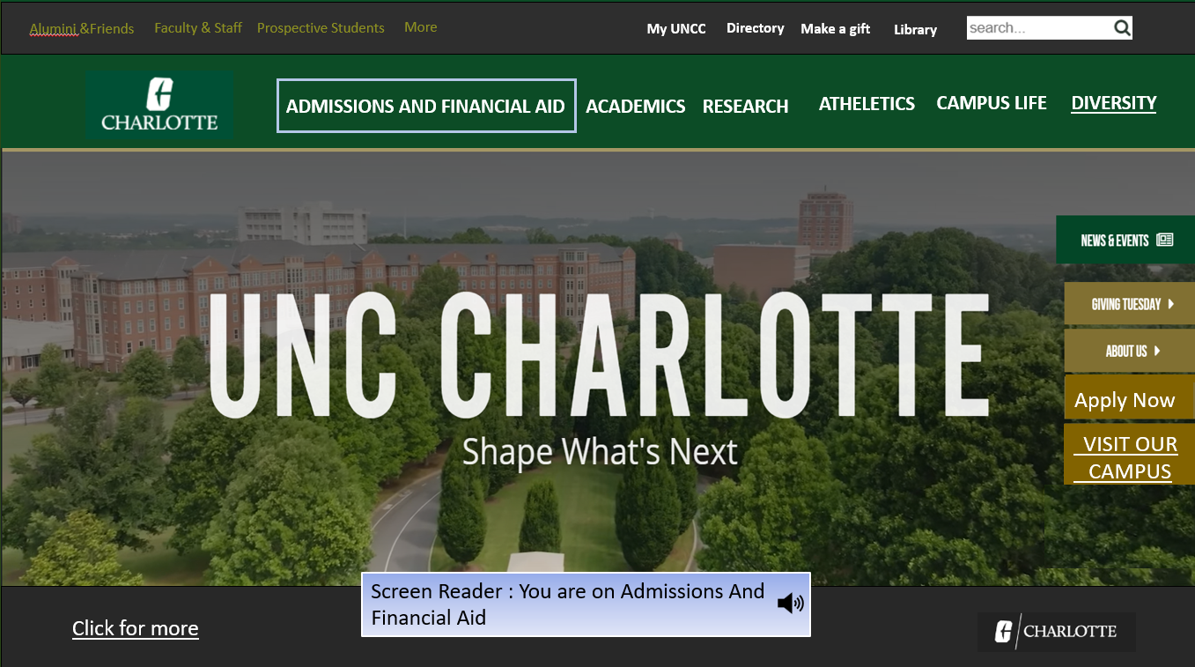

2)Contrast and design optimization: Enhance color contrast and design elements to improve visibility for visually impaired users, such as larger fonts, distinct color schemes, and clear visual hierarchies.

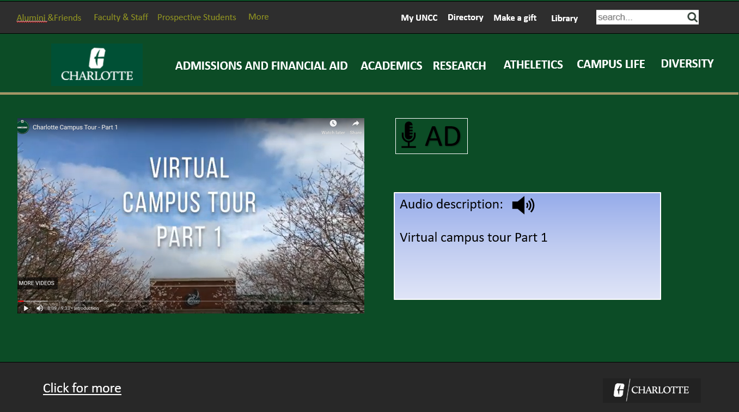

3)accessible to visually impaired students, offering options like text-to-speech functionality and screen reader compatibility

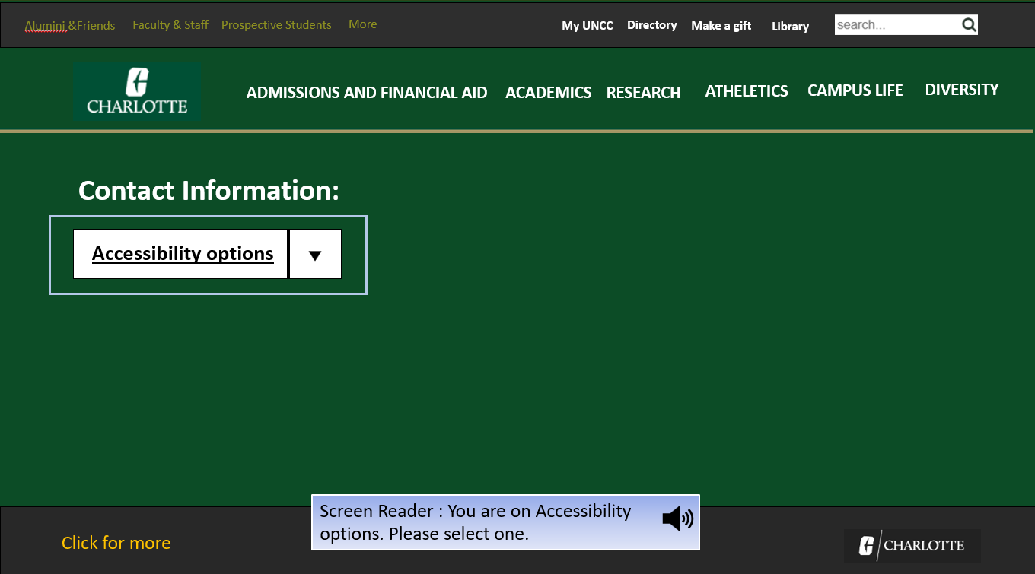

4)Provide direct contact information, such as an email or phone number, for a diversity department or specific staff dedicated to assisting students like Amy in finding inclusive programs.

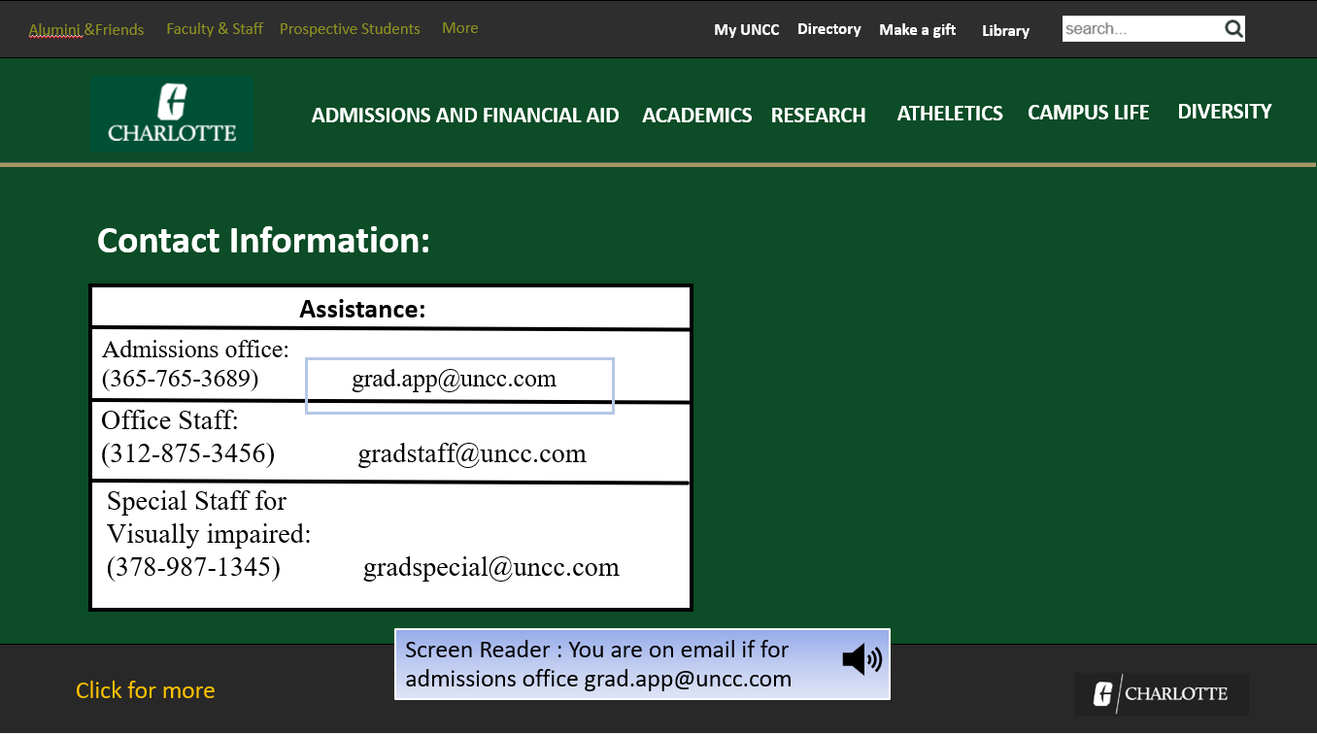

5)Offered Clear Statistical Information: Presented diversity statistics in a structured and easily accessible format, ensuring they are compatible with screen readers and other assistive technologies for visually impaired users.

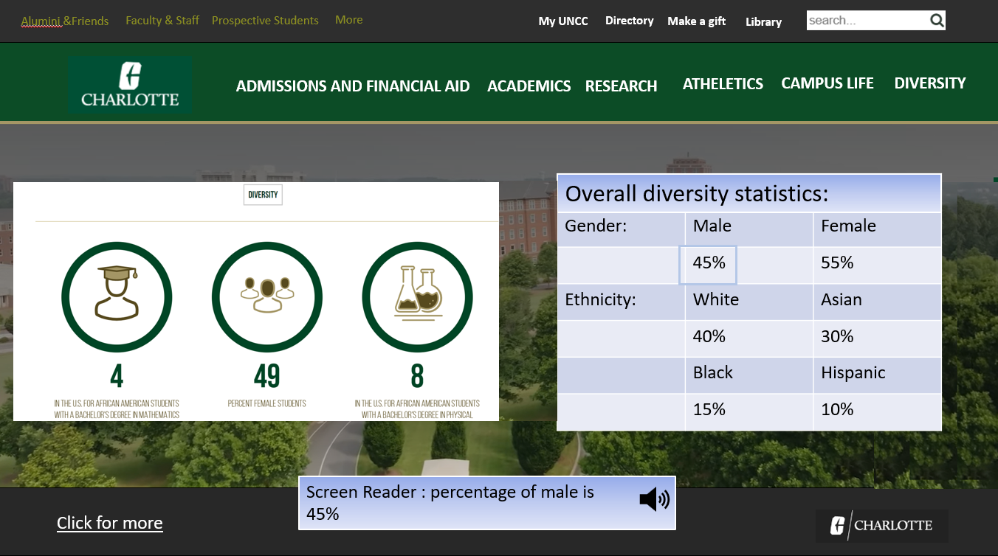

**4)Changes Description:**

Articulate description of changes made:

1)Embedded Alternative Text Descriptions for Images:

All images and texts now include concise and descriptive alternative text. This implementation ensures that screen readers can effectively convey information to visually impaired users. By providing alternative text, users like Amy can comprehend the content of images, which contributes to a more inclusive browsing experience.

2)Clear and Structured Navigation:

The website's navigation has undergone simplification, featuring clearly labeled sections and headings. This adjustment is designed to assist users, especially those with visual impairments, in understanding and traversing the site more easily. A structured navigation system ensures that users can quickly locate and access the information they seek, contributing to a more user-friendly experience.

3)Contrast and Design Optimization:

To improve visibility for visually impaired users, various design elements have been optimized. This includes enhanced color contrast, larger fonts, distinct color schemes, and clear visual hierarchies. These changes aim to make content more legible and distinguishable, creating a visually comfortable experience for users with impaired vision.

4)Accessibility Features for Visually Impaired Students:

The design now incorporates features specifically catering to visually impaired students. This includes text-to-speech functionality and compatibility with screen readers. These accessibility options empower users like Amy to engage with the content more effectively, ensuring a more inclusive experience.

5)Direct Contact Information for Diversity Support:

A direct and easily accessible contact information section has been added for a diversity department or specific staff dedicated to assisting students like Amy. This change provides a straightforward channel for Amy to reach out for support and information about inclusive programs, fostering a more personalized and supportive environment.

6)Clear Presentation of Diversity Statistics:

Diversity statistics are now presented in a structured and easily accessible format. This presentation is compatible with screen readers and other assistive technologies, ensuring that visually impaired users can access and understand the statistical information effectively. Clarity in presenting this data contributes to informed decision-making for prospective students like Amy.

**5)Improvements and Refinements:**

**Demonstration of how changes address identified issues.**

**The improvements and refinements made to the design effectively address the identified issues to enhance the overall user experience, especially for visually impaired students like Amy. Here's a demonstration of how each change specifically addresses the previously identified issues:**

**Embedded Alternative Text Descriptions for Images:**

**Identified Issue: Lack of inclusive design features hindering accessibility for visually impaired students.**

**How it Addresses the Issue: By embedding alternative text, this change directly addresses the absence of descriptive information for images. Visually impaired users, including Amy, can now gain a comprehensive understanding of visual content through screen readers.**

**Clear and Structured Navigation:**

**Identified Issue: Frustration and hindrance in accessing crucial information due to complex and unclear navigation.**

**How it Addresses the Issue: Simplifying the website's navigation with clear labels and headings directly tackles the frustration caused by unclear pathways. This change ensures that visually impaired users can easily navigate the site and find the information they need.**

**Contrast and Design Optimization:**

**Identified Issue: Lack of visibility and legibility for visually impaired users.**

**How it Addresses the Issue: Enhanced color contrast, larger fonts, and distinct visual hierarchies directly address the issue of visibility. These optimizations contribute to a more visually comfortable experience, allowing users with impaired vision to engage more effectively with the content.**

**Accessibility Features for Visually Impaired Students:**

**Identified Issue: Specific needs of visually impaired students not met, resulting in a barrier to accessing crucial information.**

**How it Addresses the Issue: Incorporating features like text-to-speech and screen reader compatibility tailors the design to the specific needs of visually impaired students. This change removes barriers, making the content more accessible and usable for users like Amy.**

**Direct Contact Information for Diversity Support:**

**Identified Issue: Absence of clear pathways and direct contact points for accessing diversity information and support.**

**How it Addresses the Issue: Providing direct contact information for a diversity department directly addresses the identified issue. This change offers a clear pathway for users, like Amy, to seek support and information about inclusive programs, ensuring a more personalized experience.**

**Clear Presentation of Diversity Statistics:**

**Identified Issue: Difficulty in accessing statistical insights about the college's diversity.**

**How it Addresses the Issue: Presenting diversity statistics in a structured and accessible format directly addresses the identified issue. Visually impaired users can now access and understand this information easily, contributing to informed decision-making.**

**Chapter 6: Interactive High-Fidelity Prototype :**

Prototype Quality:

* Functionality and interactivity of the prototype.
* User-friendly navigation.

The prototype excels in both functionality and interactivity, providing a dynamic and engaging user experience. Interactive elements, such as dropdown menus, clickable buttons, and intuitive forms, contribute to a seamless navigation flow. Users can effortlessly explore different sections, access information, and interact with features, enhancing the overall usability of the design.

The user-friendly navigation is a standout feature of the prototype. Clear and well-labeled menus, along with intuitive pathways, ensure that users, including those with visual impairments, can easily navigate through the website. The incorporation of direct links to key sections and the implementation of a straightforward menu structure contribute to an efficient and enjoyable user experience.

In summary, the prototype's functionality and interactivity, coupled with user-friendly navigation, create a cohesive and accessible digital environment. This design approach prioritizes ease of use, catering to the diverse needs of users, including prospective students like Amy.

2)Instructions:

**Clear instructions on how to interact with the prototype.**

**Step 1) Initiating Campus Tour:**

Locate and click on the "Visit Our Campus" button prominently displayed on the homepage.

This action triggers navigation to the campus tour section, offering users a visual exploration of the university's facilities.

**Step2) Audio Description Feature:**

While watching the campus tour video, observe the implementation of an audio description feature.

This feature ensures accessibility for visually impaired users by providing additional auditory information about the visual content.

**Step3) Accessing Contact Information:**

Look for and click on the "Click for More" option, strategically placed to provide additional details or contacts.

This action is designed to grant users access to essential contact information, fostering communication with relevant university departments.

**Step4) Exploring Accessibility Options:**

Navigate to the "Accessibility Options" section by clicking on the corresponding option.

This section is dedicated to providing information and assistance related to accessibility features for users with diverse needs.

**Step5) Information:**

Click on the "Diversity" option, which directs you to a dedicated page presenting comprehensive diversity statistics.

This page is designed for clear and accessible representation of diversity metrics, ensuring an inclusive and transparent display.

**Step6) User-Friendly Interface:**

Notice the user-friendly layout and design, allowing for intuitive navigation and clear identification of clickable elements.

The prototype prioritizes ease of use, ensuring a positive and seamless experience for all users.

**Step7) Consistent Design Language:**

Observe the consistent design language across different sections, contributing to a cohesive and visually appealing prototype.

Consistency enhances the user experience by creating a familiar environment as users navigate through various features.

**Step8) Transparent Multimedia Features:**

Appreciate the transparency in multimedia features, such as the audio description during video playback.

This transparency ensures that users are informed about available features, promoting inclusivity and user satisfaction.

**Step9) Enhanced Information Accessibility:**

Recognize the focus on enhanced information accessibility, with dedicated sections like "Accessibility Options" and "Diversity."

These sections cater to specific user needs, providing targeted information and assistance to create a more inclusive digital space.